PRESS RELEASE

FOR IMMEDIATE RELEASE

Clean Water Supply is Guaranteed at the ASEAN Summit in Labuhan Bajo

Labuan Bajo, East Nusa Tenggara, Kominfo Newsroom - West Manggarai Resort Police Chief AKBP Ari Satmoko ensured the readiness of clean water during the 42nd ASEAN Summit in Labuan Bajo, East Nusa Tenggara.

"As the host, we must provide the utmost service for heads of state and entourage in security and availability of the needs of state guests. One of which is clean drinking water," he said in Labuan Bajo on Tuesday, 18 April 2023.

He said the West Manggarai Police paid attention to the availability of clean drinking water for the community and tourists visiting Labuan Bajo.

He wants the Drinking Water Treatment System (SPAM), which has been operated since July 2022, to meet the water needs of the tourism destination area.

Meanwhile, the President Director of the Regional DrinkingSOAM Water Company (PERUMDA) Wae Mbeliling, Aurelius Hubertus Endo, explained that the Wae Mese II SPAM is to anticipate the lack of clean drinking water, especially in the City of Labuan Bajo and its surroundings.

Wae Mese II SPAM can process 100 liters of water per second, complementing the Wae Mese SPAM with 40 liters per second.

Wae Mese II SPAM was built with an investment value of up to IDR 159 billion in 2020 to provide clean drinking water for the people in Labuan Bajo: as many as 8,000 house connections or the equivalent of 40 thousand people.

"The water source comes from the Wae Mese River and channels to the Wae Mata Reservoir with a capacity of 2,000 cubic meters to serve five reservoirs, namely the Bappeda, Golokoe, Firdaus, Batu Cermin Caves, and DPRD reservoirs," he said.

West Manggarai Police Chief AKBP Ari Satmoko personally inspected the Wae Mese II Drinking Water Treatment System (SPAM), located in Watu Nggelek Village, Komodo District, Monday, 17 April 2023. (Fransiska/Elvira/TR)

***

Director General of Public Information and Communications of the Ministry of Communication and Informatics – Usman Kansong (0816785320).

Get more information at https://infopublik.id.

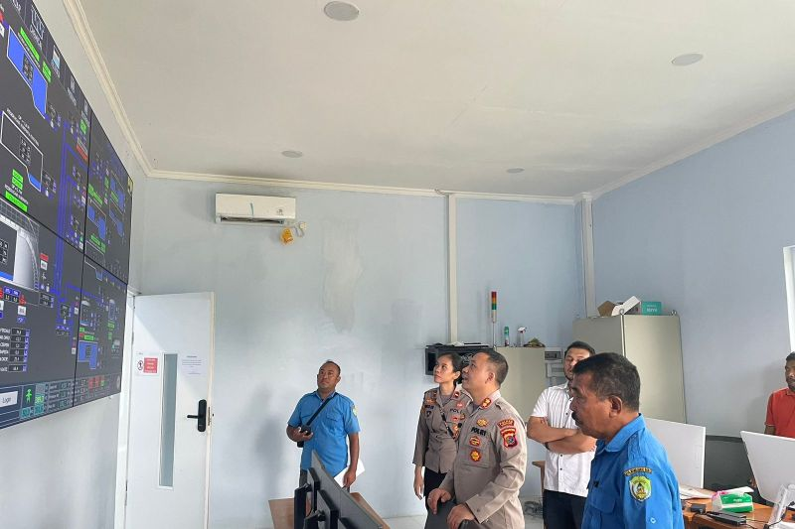

West Manggarai Police Chief AKBP Ari Satmoko inspected the Wae Mese II Drinking Water Treatment System (SPAM), Labuan Bajo, West Manggarai, East Nusa Tenggara, Monday, 17 April 2023. (ANTARA PHOTO/HO-West Manggarai Police)

